Classification Of Arecanut Using Image Processing

ABSTRACT

In this paper, a novel method developed for classification of arecanuts based on texture features. A Gabor response cooccurrence matrix (GRCM) is constructed analogous to Gray Level co-occurrence matrix (GLCM). Classification is done using LBP algorithm and classifier based on GRCM features. There are twelve Gabor filters are designed (Four orientations and three scaling) to capture variations in lighting conditions. The LBP operator is a powerful means of micro texture description that has been used in texture analysis of arecanut. The Gabor filters and GLCM will capture data with different scale and angle. The LBP based Gabor and GLCM features have been used for classification of arecanut. LBP is applied on arecanut image then Gabor filters and GLCM have been applied on LBP image. The images are normalized to 300x300 sizes in order to improve the processing time. The results are compared and discussed exhaustively with Histogram correlation, GLCM, Gabor and combined (Gabor-GLCM) features.

1.INTRODUCTION

Arecanut palm (Areca catechu L.,) family Palmae is the source of arecanut referred to as betelnut or supari in India. It is used in Indian and other South countries as a masticatory. It forms one of the ingredients of betel quid commonly in India. India accounts for about 57 percent of world production. In the classification of arecanut, color and texture are the most important parameters that allows for the evaluation of their degree of quality, and existence of faults. Also, color along with its level of homogeneity influences the degree of acceptance of consumers, as well as the pricing. There are six types of arecanuts considered for this work, namely Api, Red Bette (RB), Black Bette (BB), Minne, Gotu and Chaali. In the proposed method, arecanuts are classified using Gabor response co-occurrence matrix (GRCM) features like Contrast, Correlation, Energy and Homogeneity. An experiment is conducted using kNN classifier and Decision tree classifier and the results are discussed. Survey has been conducted and collected samples from about 15 agricultural fields and eight tender markets.

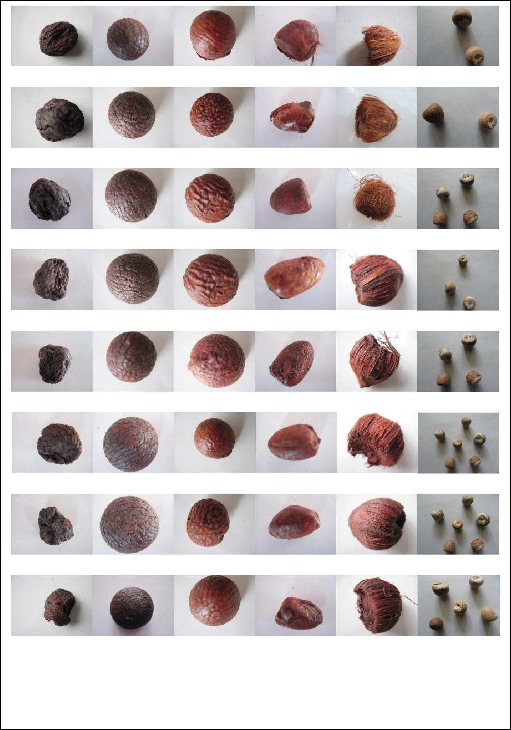

Api Black Bett Red Bette (d) Minne (e) Gotu (f) Chaali

Figure 1: Sample arecanut dataset without husk.

2. PROBLEM DEFINITION

There are many grades of arecanut is available in the market. Qualitative sorting is usually performed by trained inspectors. This type of evaluation is rather expensive and is determined by operators' inconsistency and subjectivity. Machine vision technology offers objective solutions for all these problems and it is considered to be a promise for replacing the traditional human inspection methods in the field of arecanut marketing.

3. PROPOSED METHODOLOGY

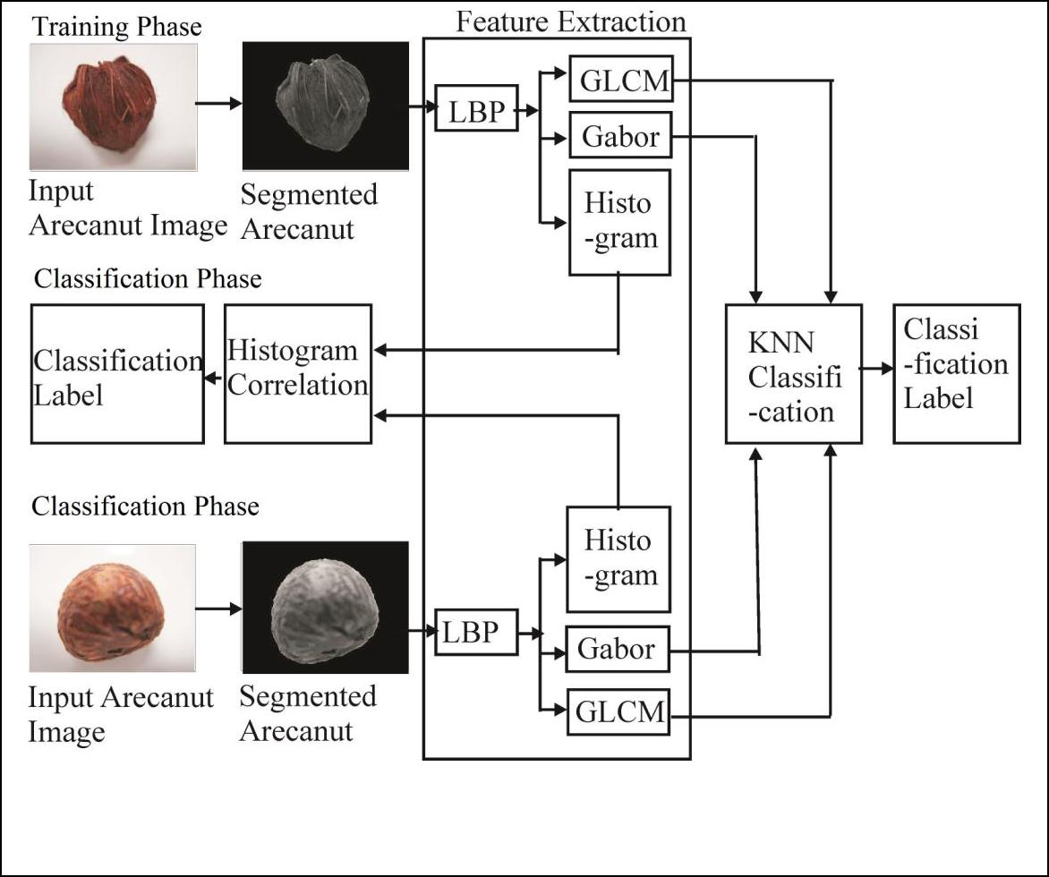In the proposed method, arecanuts are segmented from the given image. In feature extraction stage Gabor response are obtained using 12 filters. GRCM is constructed and features of GRCM like Contrast, Correlation, Energy and Homogeneity are used for classification of unknown samples using LBP algorithm.

Figure 2: Block Diagram of the proposed method.

3.1 Segmentation

The first step in arecanut classification is to segment the arecanut image. Segmentation subdivides an image into its constituent parts or objects. The level to which this subdivision is carried depends on the problem being solved. That is segmentation should stop when the objects of interest in an application image intensity. Meanwhile, Watershed segmentation also embodies other principal image segmentation methods including discontinuity detection, thresholding and region processing. Because of these factors, watershed segmentation displays more effectiveness and stableness than other segmentation algorithms Rafael C. Gonzalez et al. Watershed segmentation is an effective method for gray level arecanut image segmentation. To apply watershed segmentation to binary images, there is a need to preprocess the arecanut binary images with distance transform to convert it to gray level images which are suitable for watershed segmentation. The common Distance Transforms (DTs) include Euclidean, City block and Chessboard. Different DTs produce very different watershed segmentation results for the arecanut binary images. For arecanut images containing components of different shapes, it is found that the Chessboard DT can achieve better watershed segmentation results. Each image contains multiple intra class arecanut objects. The segmented image is labeled and each arecanut is extracted from the image as shown in Figure. 1(b) and 1(c) respectively.

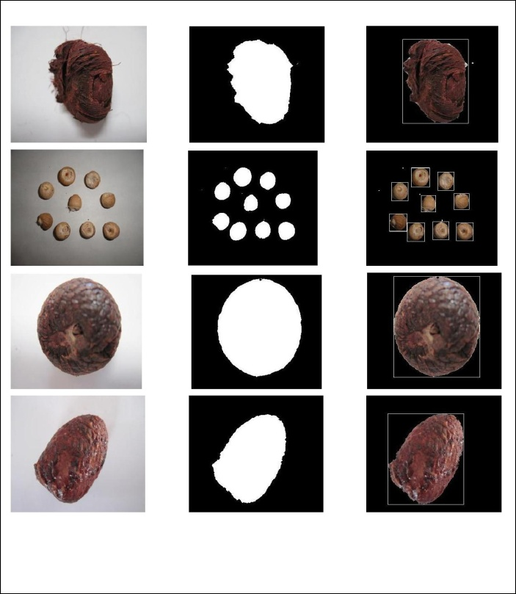

(a) Original (b) Masked (c) Segmented

Figure4.1: Sample Experimental Segmentation Results.

3.2 Feature Extraction

In the feature extraction process, obtained Gabor responses of sample data using Gabor wavelets. With this data determined GRCM features such as Contrast, Correlation, Energy and Homogeneity based on Gabor response of pixels.

3.2.1 Gabor Filter Response

Texture analysis using filters based on Gabor functions falls into the category of frequency-based approaches. These approaches are based on the premise that texture is an image pattern containing a repetitive structure that can be effectively characterized in a frequency domain, such as the Fourier domain. One of the challenges, however, of such an approachis dealing with the tradeoff between the joint uncertainty in the space and frequency domains. Meaningful frequency based analysis cannot be localized without bound. An attractive mathematical property of Gabor functions is that they minimize the joint uncertainty in space and frequency. They achieve the optimal tradeoff between localizing the analysis in the spatial and frequency domains Newsam et al.The Gabor filter is a linear filter whose impulse response is defined by a harmonic function multiplied by a Gaussian function. Because of the multiplication-convolution property (Convolution theorem), the Fourier transform of a Gabor filter's impulse response is the convolution of the Fourier transform of the harmonic function and the Fourier transform of the Gaussian function A filter bank of Gabor filters with various scales and rotations is created. In this work scaling of 0, 2, 4 and orientations of 0, 45, 90 and 135 are considered.

3.2.2 GRCM Features

Texture feature uses the contents of GRCM to measure the variation in Gabor responses at a pixel of interest. Harlick et al. first proposed in 1973, they characterize texture using a variety of quantities derived from second order image statistics. Co-occurrence texture features are extracted from an image in two steps. First, the pairwise spatial co-occurrences of pixels separated by a particular angle and distance are tabulated using GRCM approach. Second, the GRCM is used to compute a set of scalar quantities that characterize different aspects of the underlying texture. The GRCM is a tabulation of how often different combinations of Gabor responses co occur in an image or image section Harlick et al. The GRCM is N x N square matrix, where N is the size of an image. An element p(i, j, d, θ) of a GRCM of an image represents the relative frequency, where i is the Gabor response of the pixel p at allocation (x, y) , and j is the Gabor response of a pixel located at a distance d from p in the orientation θ. While GRCMs provide a quantitative description of a spatial pattern, they are too unwieldy for practical image analysis. Harlick et al. proposed a set of scalar quantities for summarizing the information contained in a Gray level co-occurrence matrix (GLCM). He originally proposed a total of fourteen features. However, only subsets of these are used Newsam et al.

3.2.3 Local Binary Pattern (LBP)

The basic local binary pattern was originally proposed by T. Ojala (1996) was based on the assumption that texture has locally two complementary aspects, a pattern and its strength with the aim of texture classification, and then extended for various fields, including face recognition (T. Ahonen, 2006) face detection (A. Hadid, 2004), facial expression recognition (G. Zhao, 2007) etc.

Guang Han et al. (2008) proposed a multi-channel local binary pattern in RGB color space as textured color features and the kNN is employed for visual training and classification. Lin C-H. et al. (2012) proposed an adaptive local binary patterns histogram and gradient for adaptive local binary patterns for image retrieval and classification. They have used color and grayscale images to generate a variety of image subsets. The authors have discovered that the feature extraction method can effectively describe the texture characteristics of images. Meiru Mu et al. (2010) proposed a novel discriminative local binary patterns statistic for palm print recognition. In this approach, a palm print is divided into non-overlapping and equal sized regions and labeled these with LBP. The Discriminative Common Vectors was applied for dimensionality reduction. The kNN classifier was used for classification. Pereira E.T. et al. (2010) proposed a new feature extraction approach that combines Integral Histograms and LBP; this novel approach is called the Integral Local Binary Patterns for face/non-face classification. Shu Liao et al. (2007) proposed a new feature extraction method in whih advanced local binary patterns with local dominant structural characteristics of different kinds of textures were introduced. The global spatial distribution features of the advanced local binary patterns were extracted by advanced local binary patterns with aura matrix measure as the second layer.

**Conclusion**

Classification of arecanut has been carried out using color and texture features. LBP is applied on arecanut image followed by Gabor filters and GLCM have been applied on LBP image. Classification of arecanut is done using different combinations such as LBP-Gabor, LBP-GLCM and LBP-Gabor-GLCM features. LBP-Gabor-GLCM features have shown better performance.